# VISVESVARAYA TECHNOLOGICAL UNIVERSITY

## BELAGAVI – 590018, Karnataka INTERNSHIP REPORT

#### ON

“Virtual Assistant for Visually Impaired”

***Submitted in partial fulfilment for the award of degree***

## BACHELOR OF ENGINEERING IN

## MECHANICAL ENGINEERING

***Submitted by:***

#### JEEVAN SANIKAM

#### 1EW20ME412



Conducted at

**CAMPSOFT TECHNOLOGY**



**EAST WEST INSTITUTE OF TECHNOLOGY**

**Department of Mechnical engineering**

**Accredited by NBA, New Delhi**

# Bangalore-560091

# 2022-2023

# EAST WEST INSTITUTE OF TECHNOLOGY

**Department of Mechanical engineering**

**Accredited by NBA, New Delhi**

# Bangalore-560091



**CERTIFICATE**

This is to certify that the Internship titled **“Virtual Assistant for Visually Impaired”** carried out by **Mr. Jeevan Sanikam (1EW20ME412),** a bonafide student of East West Institute of Technology, in partial fulfillment for the award of **Bachelor of Engineering**, in **MECHANICAL ENGINEERING** under Visvesvaraya Technological University, Belagavi, during the year 2022-2023. It is certified that all corrections/suggestions indicated have been incorporated in the report.

The project report has been approved as it satisfies the academic requirements in respect of Internship prescribed for the course Internship / Professional Practice

#### Signature of Guide Signature of HOD Signature of Principal

**External Viva:**

Name of the Examiner Signature with Date

1)

2)

# D E C L A R A T I O N

I, **Jeevan Sanikam (1EW20ME412)** , final year student of Branch, **EAST WEST INSTITUTE OF TECHNOLOGY - 560 091**, declare that the Internship has been successfully completed, in **CAMPSOFT TECHNOLOGY**. This report is submitted in partial fulfillment of the requirements for award of Bachelor Degree in Mechanical engineering, during the academic year 2022-2023.

**DATE:** 06/03/2023

**PLACE:** BANGALORE

**USN :** 1EW20ME412

**NAME :** JEEVAN SANIKAM

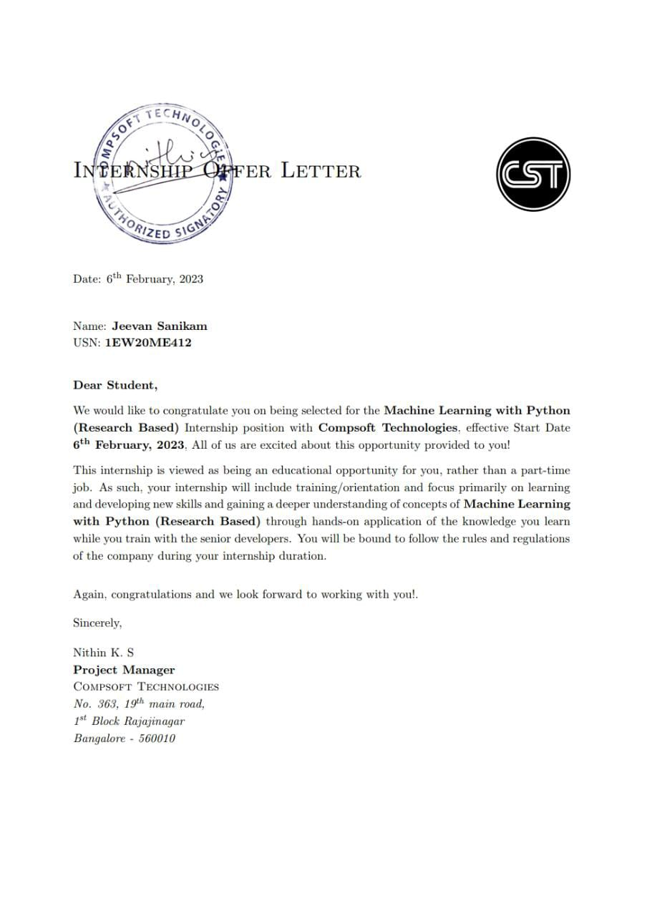

# A C K N O W L E D G E M E N T

This Internship is a result of accumulated guidance, direction and support of several important persons. We take this opportunity to express our gratitude to all who have helped us to complete the Internship.

We express our sincere thanks to our Principal, for providing us adequate facilities to undertake this Internship.

We would like to thank our Head of Dept – ME, for providing us an opportunity to carry out Internship and for his valuable guidance and support.

We would like to thank our (Lab assistant name) Software Services for guiding us during the period of internship.

We express our deep and profound gratitude to our guide, Dr. Puttaswamaih , Assistant/Associate Prof, for her keen interest and encouragement at every step in completing the Internship.

We would like to thank all the faculty members of our department for the support extended during the course of Internship.

We would like to thank the non-teaching members of our dept, for helping us during the Internship.

Last but not the least, we would like to thank our parents and friends without whose constant help, the completion of Internship would have not been possible.

**NAME : JEEVAN SANIKAM**

**USN: 1EW20ME412**

# ABSTRACT

# A person\'s ability to carry out daily duties is limited by a visual impairment, which may also impact their level of well-being and capacity to interact with the outside world. I frequently encounter visually handicapped folks whose vision loss cannot be improved. An individual\'s ability to carry out daily tasks and get around independently may be hampered by blindness. People who are blind to varying degrees can participate in peer-to-peer activities with the help of quality rehabilitation. Although most people are reluctant to use orthodontic lenses, they will like them. Modern technology is sometimes not made for the visually handicapped, making it challenging to operate. To make life\'s challenges a little easier, I decided to utilize an Android app for the blind. Therefore, this software can help those frequently dependent on others in various ways regain independence and confidence.

**Table of Contents**

|  |  |  |
| --- | --- | --- |
| **Sl no** | **Description** | **Page no** |
| 1 | Company Profile | 8-9 |
| 2 | About the Company | 10-13 |
| [3](https://1.bp.blogspot.com/-dODuK8N5h1Q/Wlnyb3V9HFI/AAAAAAAACL4/WxQtCJ1pM5wccDABg4wIrTBUB0vlikXQQCLcBGAs/s1600/poly1.jpg) | Introduction | 14-17 |
| [4](https://1.bp.blogspot.com/-dODuK8N5h1Q/Wlnyb3V9HFI/AAAAAAAACL4/WxQtCJ1pM5wccDABg4wIrTBUB0vlikXQQCLcBGAs/s1600/poly1.jpg) | System Analysis | 18-21 |
| [5](https://1.bp.blogspot.com/-dODuK8N5h1Q/Wlnyb3V9HFI/AAAAAAAACL4/WxQtCJ1pM5wccDABg4wIrTBUB0vlikXQQCLcBGAs/s1600/poly1.jpg) | Requirement Analysis | 22-23 |
| 6 | Design [Analysis](https://4.bp.blogspot.com/-IOOxgPaXMVc/Wlj3LWvcnjI/AAAAAAAACKE/UeTFYvAxDmUDel5UBjdifeWaApB3-dXVgCLcBGAs/s1600/img1.jpg) | 24-25 |
| 7 | [Implementation](https://4.bp.blogspot.com/-IOOxgPaXMVc/Wlj3LWvcnjI/AAAAAAAACKE/UeTFYvAxDmUDel5UBjdifeWaApB3-dXVgCLcBGAs/s1600/img1.jpg) | 26-27 |
| 8 | Snapshots | 28-35 |
| 9 | Conclusion | 36-37 |
| 10 | References | 38-39 |

[**CHAPTER**](https://1.bp.blogspot.com/-dODuK8N5h1Q/Wlnyb3V9HFI/AAAAAAAACL4/WxQtCJ1pM5wccDABg4wIrTBUB0vlikXQQCLcBGAs/s1600/poly1.jpg) **1** **COMPANY PROFILE**

# COMPANY PROFILE

## A Brief History of Compsoft Technologies

Compsoft Technologies, was incorporated with a goal ”To provide high quality and optimal Technological Solutions to business requirements of our clients”. Every business is a different and has a unique business model and so are the technological requirements. They understand this and hence the solutions provided to these requirements are different as well. They focus on clients requirements and provide them with tailor made technological solutions. They also understand that Reach of their Product to its targeted market or the automation of the existing process into e-client and simple process are the key features that our clients desire from Technological Solution they are looking for and these are the features that we focus on while designing the solutions for their clients.

Sarvamoola Software Services. is a Technology Organization providing solutions for all web design and development, MYSQL, PYTHON Programming, HTML, CSS, ASP.NET and LINQ. Meeting the ever increasing automation requirements, Sarvamoola Software Services. specialize in ERP, Connectivity, SEO Services, Conference Management, effective web promotion and tailor-made software products, designing solutions best suiting clients requirements.

Compsoft Technologies, strive to be the front runner in creativity and innovation in software development through their well-researched expertise and establish it as an out of the box software development company in Bangalore, India. As a software development company, they translate this software development expertise into value for their customers through their professional solutions.

They understand that the best desired output can be achieved only by understanding the clients demand better. Compsoft Technologies work with their clients and help them to defiine their exact solution requirement. Sometimes even they wonder that they have completely redefined their solution or new application requirement during the brainstorming session, and here they position themselves as an IT solutions consulting group comprising of high caliber consultants.

They believe that Technology when used properly can help any business to scale and achieve new heights of success. It helps Improve its efficiency, profitability, reliability; to put it in one sentence ” Technology helps you to Delight your Customers” and that is what we want to achieve.

# [CHAPTER](https://1.bp.blogspot.com/-dODuK8N5h1Q/Wlnyb3V9HFI/AAAAAAAACL4/WxQtCJ1pM5wccDABg4wIrTBUB0vlikXQQCLcBGAs/s1600/poly1.jpg) 2 ABOUT THE COMPANY

1. **ABOUT THE COMPANY**



Compsoft Technologies is a Technology Organization providing solutions for all web design and development, MYSQL, PYTHON Programming, HTML, CSS, ASP.NET and LINQ. Meeting the ever increasing automation requirements, Compsoft Technologies specialize in ERP, Connectivity, SEO Services, Conference Management, effective web promotion and tailor-made software products, designing solutions best suiting clients requirements. The organization where they have a right mix of professionals as a stakeholders to help us serve our clients with best of our capability and with at par industry standards. They have young, enthusiastic, passionate and creative Professionals to develop technological innovations in the field of Mobile technologies, Web applications as well as Business and Enterprise solution. Motto of our organization is to “Collaborate with our clients to provide them with best Technological solution hence creating Good Present and Better Future for our client which will bring a cascading a positive effect in their business shape as well”. Providing a Complete suite of technical solutions is not just our tag line, it is Our Vision for Our Clients and for Us, We strive hard to achieve it.

## Products of Compsoft Technologies.

**Android Apps**

It is the process by which new applications are created for devices running the Android operating system. Applications are usually developed in Java (and/or Kotlin; or other such option) programming language using the Android software development kit (SDK), but other development environments are also available, some such as Kotlin support the exact same Android APIs (and bytecode), while others such as Go have restricted API access.

The Android software development kit includes a comprehensive set of development tools. These include a debugger, libraries, a handset emulator based on QEMU, documentation, sample code, and zutorials. Currently supported development platforms include computers running Linux (any modern desktop Linux distribution), Mac OS X 10.5.8 or later, and Windows 7 or later. As of March 2015, the SDK is not available on Android itself, but softwaredevelopment is possible by using specialized Android applications.

**Web Application**

It is a client–server computer program in which the client (including the user interface and client- side logic) runs in a web browser. Common web applications include web mail, onlineretail sales, online auctions, wikis, instant messaging services and many other functions. web applications use web documents written in a standard format such as HTML and JavaScript,which are supported by a variety of web browsers. Web applications can be considered as a specifific variant of client–server software where the client software is downloaded to the client machine when visiting the relevant web page, using standard procedures such as HTTP. The Client web software updates may happen each time the web page is visited. During the session, the web browser interprets and displays the pages, and acts as the universal client for any web application. The use of web application frameworks can often reduce the number of errors in a program, both by making the code simpler, and by allowing one team to concentrate on the framework while another focuses on a specifified use case. In applications which are exposed to constant hacking attempts on the Internet, security- related problems can be caused by errors in the program.

Frameworks can also promote the use of best practices such as GET after POST. There are some who view a web application as a two-tier architecture. This can be a “smart” client that performs all the work and queries a “dumb” server, or a “dumb” client that relies on a “smart” server. The client would handle the presentation tier, the server would have the database (storage tier), and the business logic (application tier) would be on one of them or on both. While this increases the scalability of the applications and separates the display and the database, it still doesn‟t allow for true specialization of layers, so most applications will outgrow this model. An emerging strategy for application software companies is to provide web access to software previously distributed as local applications. Depending on the type of application, it may require the development of an entirely different browser-based interface, or merely adapting an existing application to use different presentation technology. These programs allow the user to pay a monthly or yearly fee for use of a software application without having to install it on a local hard drive. A company which follows this strategy is known as an application service provider (ASP), and ASPs are currently receiving much attention in the software industry.

Security breaches on these kinds of applications are a major concern because it can involve both enterprise information and private customer data. Protecting these assets is an important part of any web application and there are some key operational areas that must be included in the development process. This includes processes for authentication, authorization, asset handling, input, and logging and auditing. Building security into the applications from the beginning can be more effective and less disruptive in the long run.

**Web design**

It is encompasses many different skills and disciplines in the production and maintenance of websites. The different areas of web design include web graphic design; interface design; authoring, including standardized code and proprietary software; user experience design; and search engine optimization. The term web design is normally used to describe the design process relating to the front-end (client side) design of a website including writing mark up. Web design partially overlaps web engineering in the broader scope of web development. Web designers are expected to have an awareness of usability and if their role involves creating mark up then they are also expected to be up to date with web accessibility guidelines. Web design partially overlaps web engineering in the broader scope of web development.

## Departments and services offered

Compsoft Technologies plays an essential role as an institute, the level of education, development of student’s skills are based on their trainers. If you do not have a good mentor then you may lag in many things from others and that is why we at Compsoft Technologies gives you the facility of skilled employees so that you do not feel unsecured about the academics. Personality development and academic status are some of those things which lie on mentor’s hands. If you are trained well then you can do well in your future and knowing its importance of Compsoft Technologies always tries to give you the best.

They have a great team of skilled mentors who are always ready to direct their trainees in the best possible way they can and to ensure the skills of mentors we held many skill development programs as well so that each and every mentor can develop their own skills with the demands of the companies so that they can prepare a complete packaged trainee.

## Services provided by Compsoft Technologies.

* Core Java and Advanced Java
* Web services and development
* Dot Net Framework
* Python
* Selenium Testing
* Conference / Event Management Service
* Academic Project Guidance
* On The Job Training
* Software Training

[**CHAPTER**](https://1.bp.blogspot.com/-dODuK8N5h1Q/Wlnyb3V9HFI/AAAAAAAACL4/WxQtCJ1pM5wccDABg4wIrTBUB0vlikXQQCLcBGAs/s1600/poly1.jpg) **3**

**INTRODUCTION**

**INTRODUCTION**

## Introduction to ML

## Over the past two decades Machine Learning has become one of the mainstays of information technology and with that, a rather central, albeit usually hidden, part of our life. With the ever increasing amounts of data becoming available there is good reason to believe that smart data analysis will become even more pervasive as a necessary ingredient for technological progress. The purpose of this chapter is to provide the reader with an overview over the vast range of applications which have at their heart a machine learning problem and to bring some degree of order to the zoo of problems. After that, we will discuss some basic tools from statistics and probability theory, since they form the language in which many machine learning problems must be phrased to become amenable to solving. Finally, we will outline a set of fairly basic yet effective algorithms to solve an important problem, namely that of classification. More sophisticated tools, a discussion of more general problems and a detailed analysis will follow in later parts of the book.

**Types Of Machine Learning**

Today, Machine Learning algorithms are primarily trained using three essential methods. These are categorized as three types of machine learning, as discussed below –

**1. Supervised Learning**

One of the most elementary types of machine learning, supervised learning, is one where data is labeled to inform the machine about the exact patterns it should look for. Although the data needs to be labeled accurately for this method to work, supervised learning is compelling and provides excellent results when used in the right circumstances.

For instance, when we press play on a Netflix show, we’re informing the Machine Learning algorithm to find similar shows based on our preference.

How it works –

* The Machine Learning algorithm here is provided with a small training dataset to work with, which is a smaller part of the bigger dataset.
* It serves to give the algorithm an idea of the problem, solution, and various data points to be dealt with.
* The training dataset here is also very similar to the final dataset in its characteristics and offers the algorithm with the labeled parameters required for the problem.
* The Machine Learning algorithm then finds relationships between the given parameters, establishing a cause and effect relationship between the variables in the dataset.

**2. Unsupervised Learning**

Unsupervised learning, as the name suggests, has no data labels. The machine looks for patterns randomly. It means that there is no human labor required to make the dataset machine-readable. It allows much larger datasets to be worked on by the program. Compared to supervised learning, unsupervised [Machine Learning services](https://marutitech.com/machine-learning-services/) aren’t much popular because of lesser applications in day-to-day life.

How does it work?

* Since unsupervised learning does not have any labels to work off, it creates hidden structures.
* Relationships between data points are then perceived by the algorithm randomly or abstractly, with absolutely no input required from human beings.
* Instead of a specific, defined, and set problem statement, unsupervised learning algorithms can adapt to the data by changing hidden structures dynamically.

**3. Reinforcement Learning**

Reinforcement learning primarily describes a class of machine learning problems where an agent operates in an environment with no fixed training dataset. The agent must *know*how to work using feedback.

How does it work?

* Reinforcement learning features a machine learning algorithm that improves upon itself.
* It typically learns by trial and error to achieve a clear objective.
* In this Machine Learning algorithm, favorable outputs are *reinforced* or encouraged, whereas non-favorable outputs are discouraged.

## Problem Statement

A machine learning problem statement typically involves defining a task or objective that can be solved using ML techniques. This task may involve predicting a value or class label based on input data, identifying patterns or anomalies in a dataset, or clustering data into groups based on similarities.

For example, a machine learning problem statement might be to predict the likelihood of a customer purchasing a product based on their past purchase history and demographic information. Another example might be to classify images of animals based on their species.

To create a machine learning problem statement, it is important to define the problem clearly and identify the relevant data sources and features that will be used to train the model. The problem statement should also include any constraints or requirements for the solution, such as accuracy thresholds or real-time processing requirements.

In addition to defining the problem statement, it is also important to select an appropriate ML algorithm and evaluate its performance using relevant metrics. This may involve splitting the data into training and testing sets, tuning model parameters, and comparing the results of different algorithms.

Overall, creating a well-defined machine learning problem statement is a critical first step in developing an effective ML solution, and requires careful consideration of the problem domain, available data, and desired outcomes

[**CHAPTER**](https://1.bp.blogspot.com/-dODuK8N5h1Q/Wlnyb3V9HFI/AAAAAAAACL4/WxQtCJ1pM5wccDABg4wIrTBUB0vlikXQQCLcBGAs/s1600/poly1.jpg) **4**

**SYSTEM ANALYSIS**

**4. SYSTEM ANALYSIS**

## Existing System

## Based on innovation and technology the Android application is promising to academically empower the blind people while freeing them from their dependence on visuals by giving the data via app. The main aim is to offer better functionalities which can make the partially blind person utilize it for recognition, identification, navigation and achieving the information about outer world. The app contains the chatbot and it will ask questions about weather, time or anything for obtaining the information or performing some actions as per user desires. It detects the objects in timely and gives the essential data to the users. In addition this app contains a barcode scanner that helps the user for obtaining information of particular products. Moreover this app helps the user for detecting the faces thus the user may know the presence of human in their surroundings and the number of people presence in that room. This application has a text reader which is utilized for reading the text as louder to a user. This system contains 5 modules of device that are accessed through voice commands and its architecture will be developed by a python interpreter. The arts Deep Learning (DL) states like capturing the image, detection of object and Optical Character Recognition (OCR) would be utilized for developing the functionalities of system. The assistive chatbot is developed using AIML (Artificial Intelligence Markup Language).

## 

## The architecture of speech based virtual assistant system and it illustrates the interfacing of various system modules for voice over conversations. In this system, the modules are image captioning, voice-over chatbot, object detection, face recognition, recognition and reading of text. In this entire system, a user may communicate with the software through the speech-to-text interface module. The speech-to-text Google library (recognition of speech) for Python will be utilized for these purposes. For providing the output Input Speech Python Modules with AI, ML and image processing for android Voice over Chatbot module Face Recognition Module Object Detection Module Text recognition Module Website Module Output Speech of system to user and confirming the inputs of user, recognized input will be played back to user by the text-to-speech module of Python.

## Proposed System

## We introduced so many features like date-time speech, location detection speech, battery level by speech and many more I think these features will help for visually impaired people. We also worked on accuracy to improve compared to other system, As we developed only front end and also it is having features mentioned above.

As I compared program done by me and src code sent by company some errors are presented in program I tried to resolve those errors and also I solved some of them some errors like file not found error cannot be resolved because the file not found on the source code sent by company. I also attached at a snapshot section what are all the error I got and I solved.

The accuracy between code done by me and the testing code is bit more accurate because I made some extra activities in this project also increased accuracy.

I introduced some topics like

* Youtube operating via voice recognition.
* Location access.
* Dictionary by voice.

## Objective of the System

## The main objectives of building this project are:

## To make the visually impaired people independently.

## To make a system which reaches them without any error and Bugs.

## Contribution to a society.

## We are making our project for blind people so we will implement functionalities from their point of view. The first and the most basic objective is to make a system that can recognise the users speech and reply on those commands. A system that can do the basic functionalities like introducing itself with user, greeting user, telling time or date or day. To make a system that can operate for the work which requires the use of web browser like opening chrome, opening youtube or searching on wikipedia etc. Also, to make a system which can open various applications for user after getting the voice commands from user. We will implement a function so that our virtual assistant can do the arithmetic operations as well. Once all of these features are implemented in our virtual assistant then we will try to add some more functionalities in it to make it more helpful.

# 

# 

# [CHAPTER](https://1.bp.blogspot.com/-dODuK8N5h1Q/Wlnyb3V9HFI/AAAAAAAACL4/WxQtCJ1pM5wccDABg4wIrTBUB0vlikXQQCLcBGAs/s1600/poly1.jpg) 5

# REQUIREMENT ANALYSIS

# 

**5. REQUIREMENT ANALYSIS**

## Hardware Requirement Specification

• Processor: Intel core i5 processer

• Memory: 15.6 GB

• Hard Disk: 40 GB

## Software Requirement Specification

1. VSCODE

2. Python 3.9

3. Android Device

4.Google collab

**VSCODE**

Visual Studio Code is a source-code editor that can be used with a variety of programming languages, including C, C#, C++, Fortran, Go, Java, JavaScript, Node. js, Python, Rust. It is based on the Electron framework, which is used to develop Node. js web applications that run on the Blink layout engine.

**PYTHON 3.9**

Python 3.9 is the last version providing those Python 2 backward compatibility layers, to give more time to Python projects maintainers to organize the removal of the Python 2 support and add support for Python 3.9. Aliases to Abstract Base Classes in the collections module, like collections.

**ANDROID DEVICE**

Android is a mobile operating system based on a modified version of the Linux kernel and other open-source software, designed primarily for touchscreen mobile devices such as smartphones andtablets.

# [CHAPTER](https://1.bp.blogspot.com/-dODuK8N5h1Q/Wlnyb3V9HFI/AAAAAAAACL4/WxQtCJ1pM5wccDABg4wIrTBUB0vlikXQQCLcBGAs/s1600/poly1.jpg) 6 DESIGN ANALYSIS

1. **DESIGN & ANALYSIS**

# Step1) import pyttsx3 library pyttsx3 is a text-to-speech conversion library in Python. Unlike alternative libraries, it works offline, and is compatible with both Python 2 and 3.

# Step2) Initialize sapi5 using pyttsx3.init() method Microsoft Speech API (SAPI5) is the technology for voice recognition and synthesis provided by Microsoft.

# Step3) Set male or female voice using engine.setProperty() method

# Step4) Define a method and give parameter in it.

# Step5) Then here the virtual assistant voice using engine.say() method

# Step6) import speech_recognition as sr Used to recognise users speech

# Step7) Use sr.Recognizer() method to recognition.

# Step8) Then use sr.Microphone() as a source to speech recognition Step9) Then input audio using r.listen() method

# Step10) Then use recognize_google() method to understand audio input which will be in English -India format.

# 

# [CHAPTE](https://1.bp.blogspot.com/-dODuK8N5h1Q/Wlnyb3V9HFI/AAAAAAAACL4/WxQtCJ1pM5wccDABg4wIrTBUB0vlikXQQCLcBGAs/s1600/poly1.jpg)R 7 IMPLEMENTATION

1. **IMPLEMENTATION**

Implementation is the stage where the theoretical design is turned into a working system. The most crucial stage in achieving a new successful system and in giving confidence on the new system for the users that it will work efficiently and effectively.

The system can be implemented only after thorough testing is done and if it is found to work according to the specification. It involves careful planning, investigation of the current system and it constraints on implementation, design of methods to achieve the change over and an evaluation of change over methods a part from planning.

Two major tasks of preparing the implementation are education and training of the users and testing of the system. The more complex the system being implemented, the more involved will be the system analysis and design effort required just for implementation.

The implementation phase comprises of several activities. The required hardware and software acquisition is carried out. The system may require some software to be developed. For this, programs are written and tested. The user then changes over to his new fully tested system and the old system is discontinued.

## TESTING

The testing phase is an important part of software development. It is the Information zed system will help in automate process of finding errors and missing operations and also a complete verification to determine whether the objectives are met and the user requirements are satisfied. Software testing is carried out in three steps:

1. The first includes unit testing, where in each module is tested to provide its correctness, validity and also determine any missing operations and to verify whether the objectives have been met. Errors are noted down and corrected immediately.
2. Unit testing is the important and major part of the project. So errors are rectified easily in particular module and program clarity is increased. In this project entire system is divided into several modules and is developed individually. So unit testing is conducted to individual modules.
3. The second step includes Integration testing. It need not be the case, the software whose modules when run individually and showing perfect results, will also show perfect results when run as a whole.

# [CHAPTE](https://1.bp.blogspot.com/-dODuK8N5h1Q/Wlnyb3V9HFI/AAAAAAAACL4/WxQtCJ1pM5wccDABg4wIrTBUB0vlikXQQCLcBGAs/s1600/poly1.jpg)R 8 SNAPSHOTS

* 1. **SNAPSHOTS**

**Output for redirecting to youtube by voice recognition**

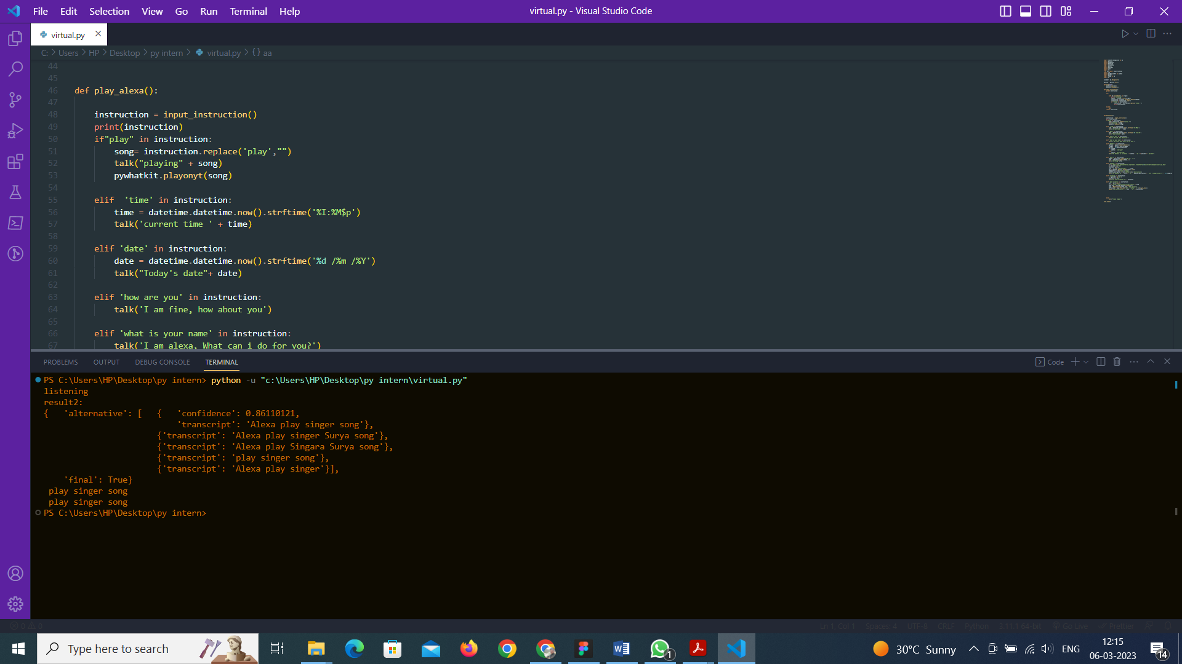

**Output for time speech by voice recognition**

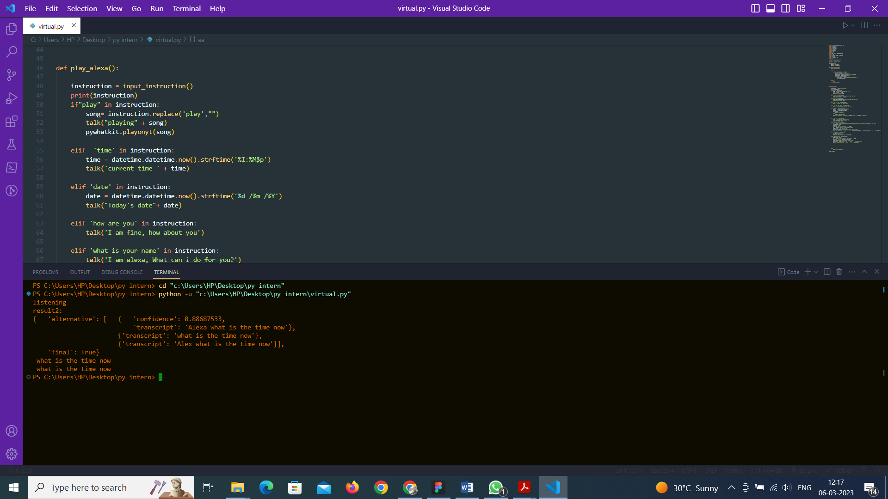

**Output for time speech by voice recognition**

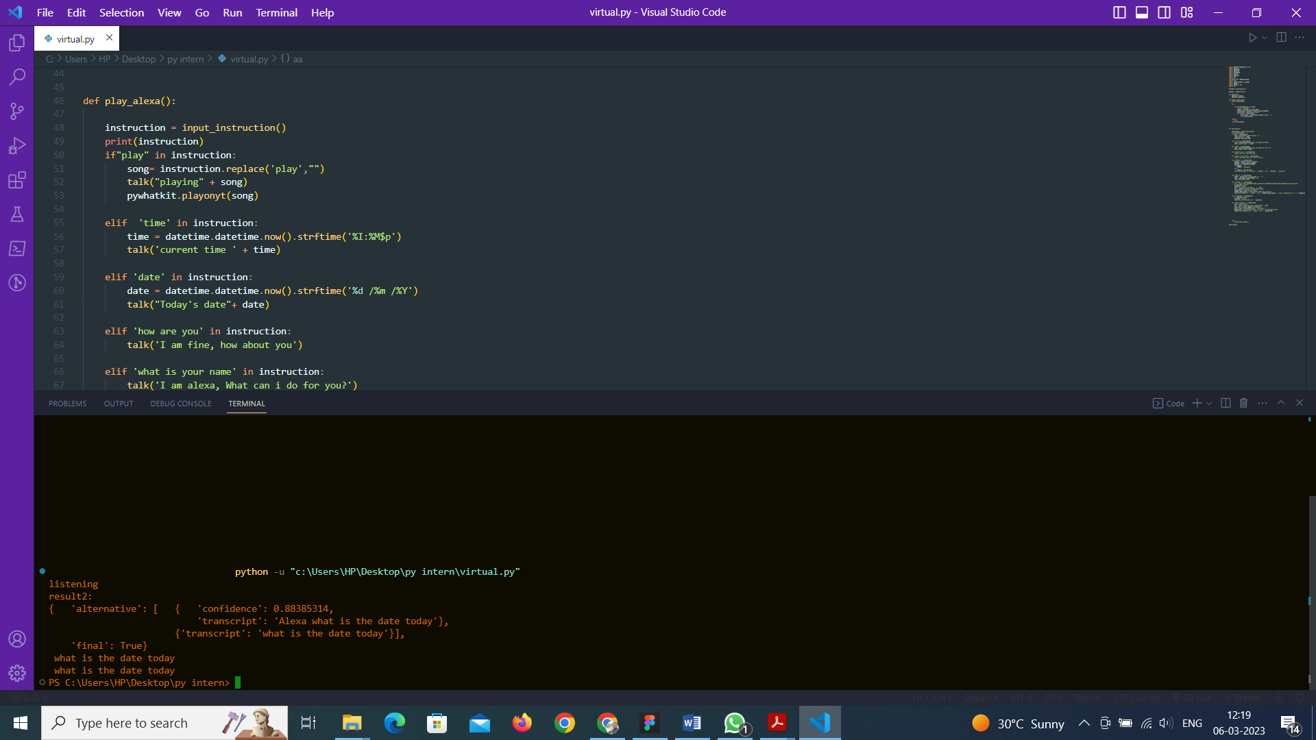

**Battery percentage by voice recognition**

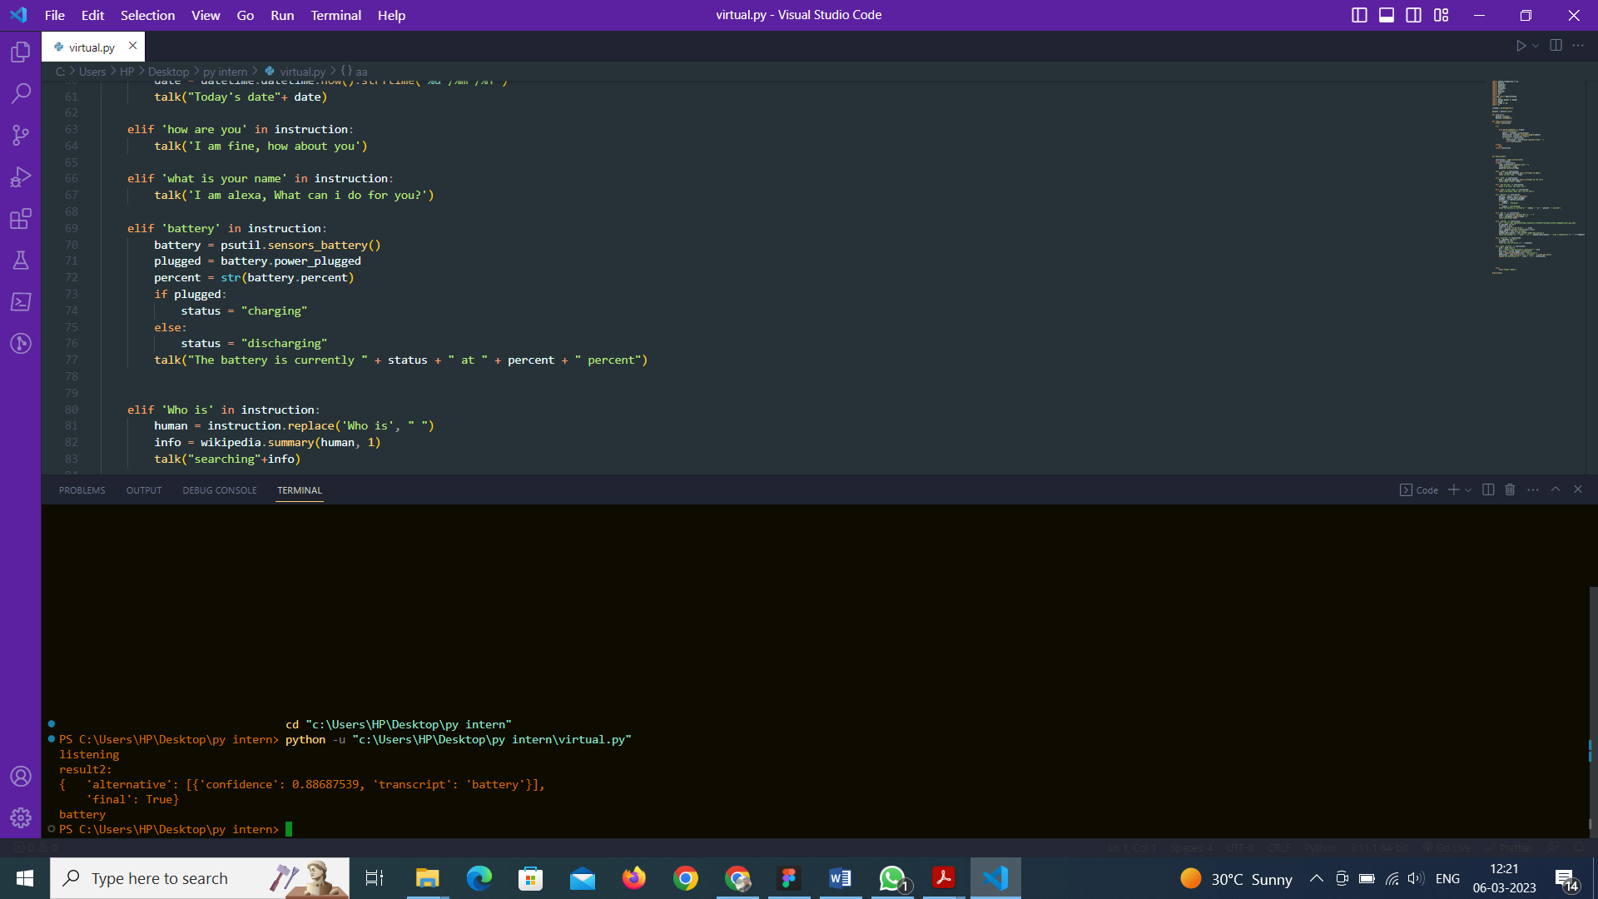

**Location detection by speech by voice recognition**

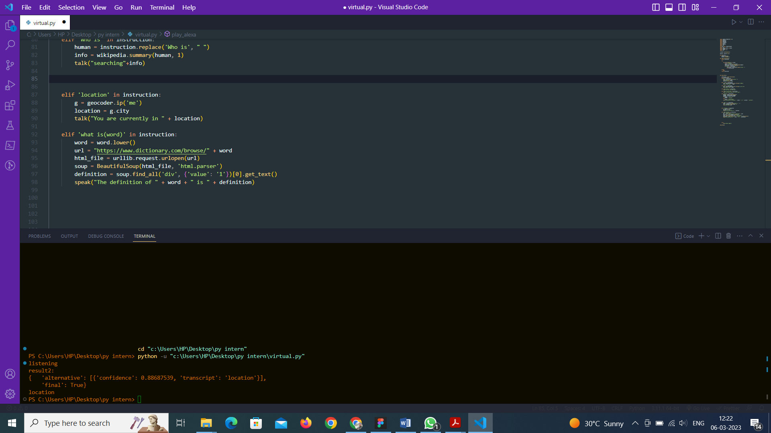

**Dictionary speech by voice recognition**

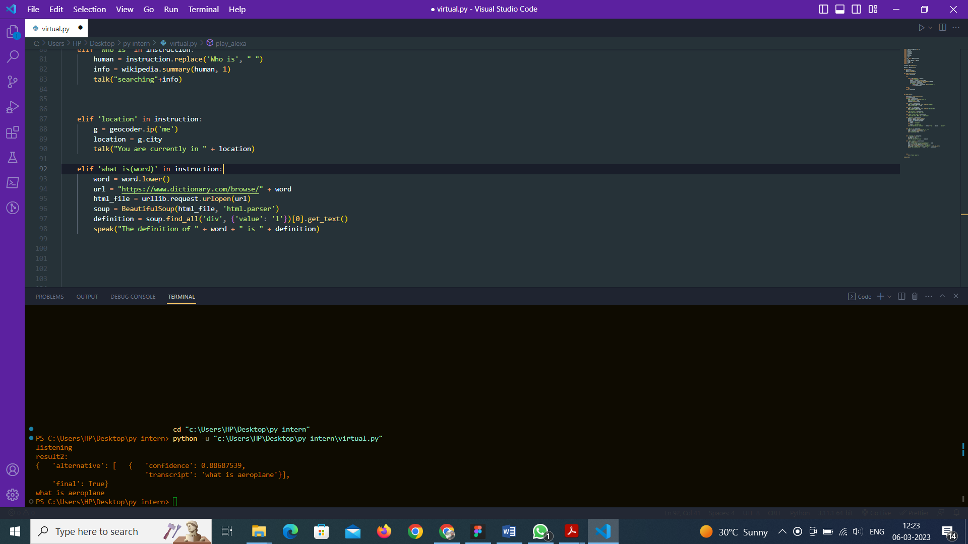

**Python program for virtual assistance for visually impaired**

import speech_recognition as aa

import pyttsx3

import pywhatkit

import datetime

import wikipedia

import psutil

import geocoder

import json

import re

from bs4 import BeautifulSoup

import cv2

import pyzbar.pyzbar as pyzbar

import pyzbar

import numpy as np

import os

listener= aa.Recognizer()

machine = pyttsx3.init()

def talk(text):

    machine.say(text)

    machine.runAndWait()

def input_instruction():

    global instruction

    try:

        with aa.Microphone() as origin:

            print("listening")

            speech = listener.listen(origin)

            instruction= listener.recognize_google(speech)

            instruction= instruction.lower()

            if "alexa" in instruction:

                 instruction = instruction.replace('alexa','')

                 print(instruction)

    except:

        pass

    return instruction

def play_alexa():

    instruction = input_instruction()

    print(instruction)

    if"play" in instruction:

        song= instruction.replace('play',"")

        talk("playing" + song)

        pywhatkit.playonyt(song)

    elif  'time' in instruction:

        time = datetime.datetime.now().strftime('%I:%M$p')

        talk('current time ' + time)

    elif 'date' in instruction:

        date = datetime.datetime.now().strftime('%d /%m /%Y')

        talk("Today's date"+ date)

    elif 'how are you' in instruction:

        talk('I am fine, how about you')

    elif 'what is your name' in instruction:

        talk('I am alexa, What can i do for you?')

    elif 'battery' in instruction:

        battery = psutil.sensors_battery()

        plugged = battery.power_plugged

        percent = str(battery.percent)

        if plugged:

            status = "charging"

        else:

            status = "discharging"

        talk("The battery is currently " + status + " at " + percent + " percent")

    elif 'Who is' in instruction:

        human = instruction.replace('Who is', " ")

        info = wikipedia.summary(human, 1)

        talk("searching"+info)

    elif 'location' in instruction:

        g = geocoder.ip('me')

        location = g.city

        talk("You are currently in " + location)

    elif 'what is(word)' in instruction:

        word = word.lower()

        url = "https://www.dictionary.com/browse/" + word

        html_file = urllib.request.urlopen(url)

        soup = BeautifulSoup(html_file, 'html.parser')

        definition = soup.find_all('div', {'value': '1'})[0].get_text()

        speak("The definition of " + word + " is " + definition)

    else:

        talk('Please repeat')

play_alexa()

**Error I found that the file dosent exists(testing of source code sent by company)**

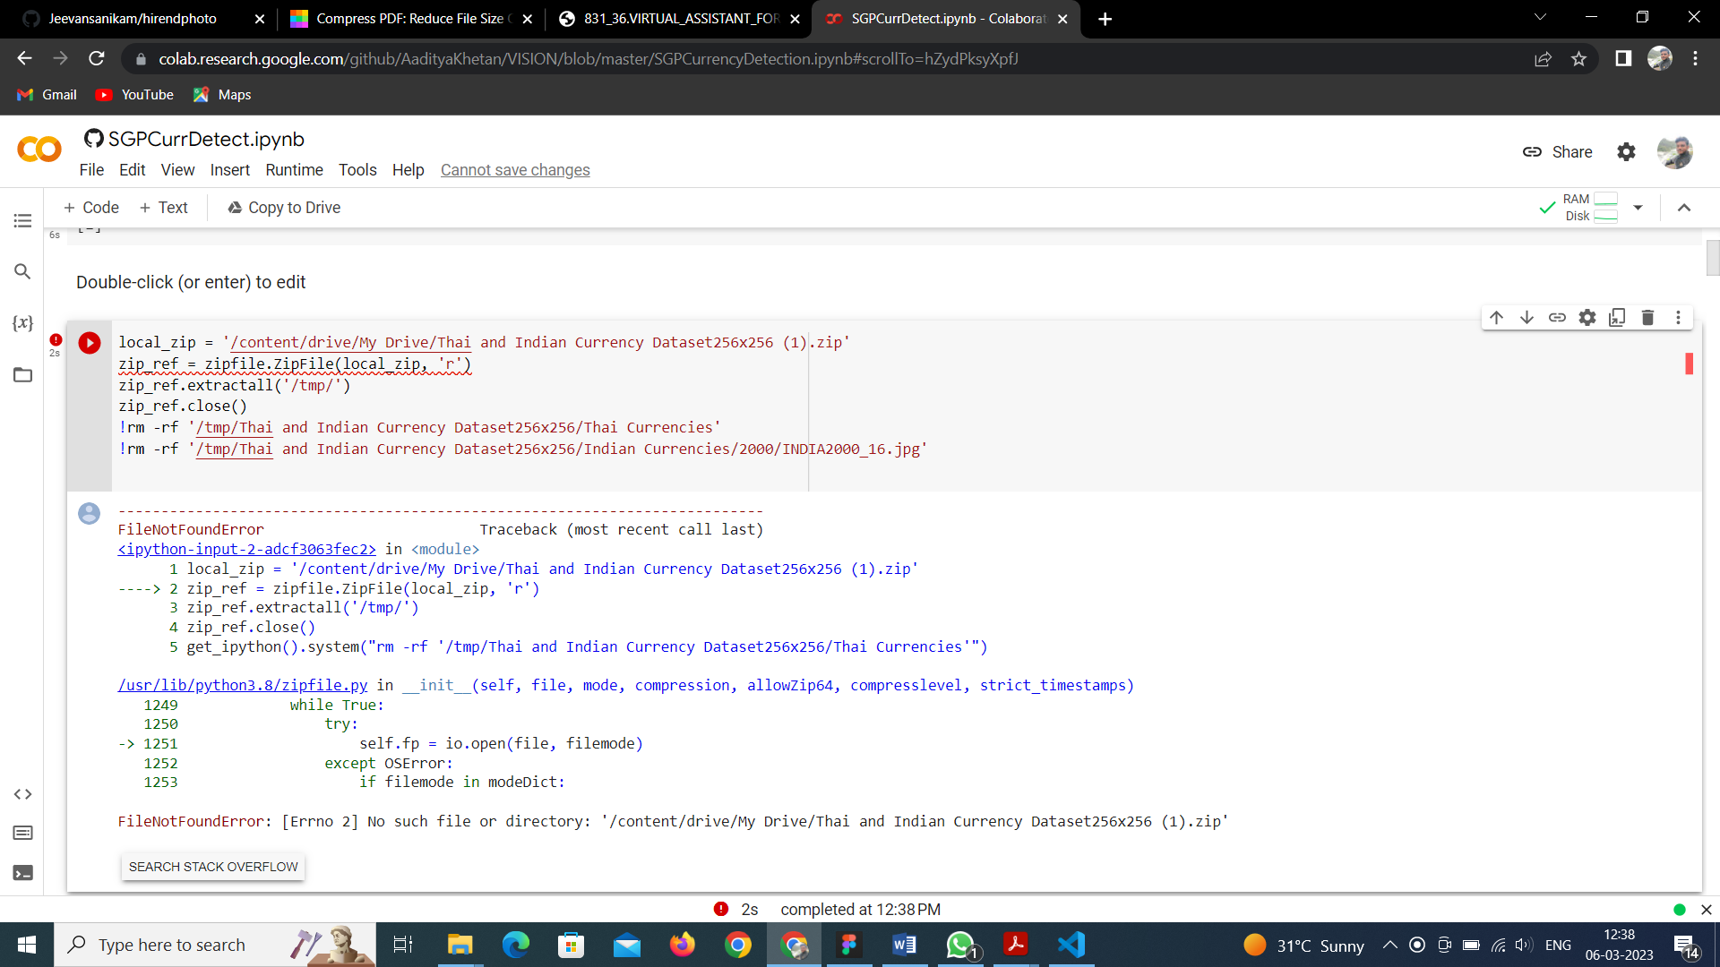

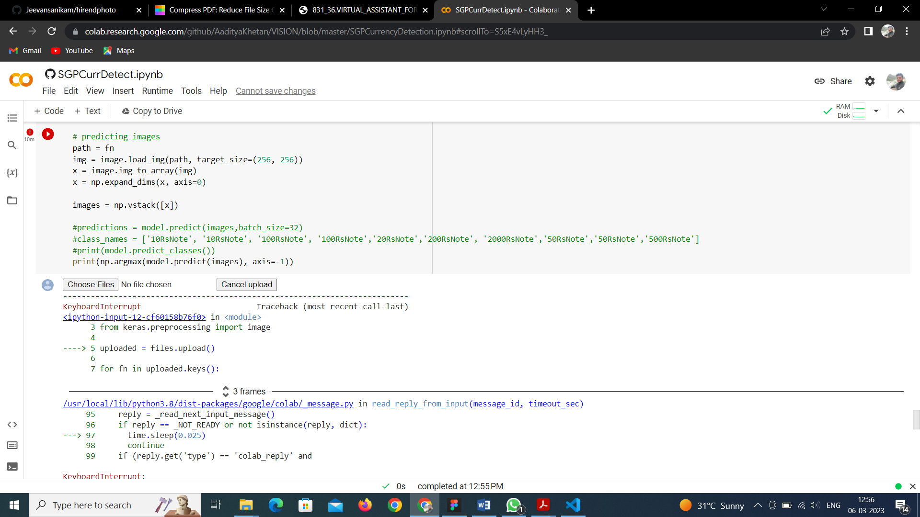

# [CHAPTE](https://1.bp.blogspot.com/-dODuK8N5h1Q/Wlnyb3V9HFI/AAAAAAAACL4/WxQtCJ1pM5wccDABg4wIrTBUB0vlikXQQCLcBGAs/s1600/poly1.jpg)R 9 CONCLUTION

* 1. **CONCLUTION**

The package was designed in such a way that future modifications can be done easily. The following conclusions can be deduced from the development of the project:

* Automation of the entire system improves the efficiency
* It provides a friendly graphical user interface which proves to be better when compared to the existing system.
* It gives appropriate access to the authorized users depending on their permissions.
* It effectively overcomes the delay in communications.
* Updating of information becomes so easier
* System security, data security and reliability are the striking features.
* The System has adequate scope for modification in future if it is necessary.

**CHAPTER 10**

**REFERENCE**

**10.REFERENCE**

* <https://www.compstechnologies.com/>
* <http://www.ijasret.com/VolumeArticles/FullTextPDF/831_36.VIRTUAL_ASSISTANT_FOR_BLIND_PEOPLE.pdf>
* The website for American foundation for the blind [https://www.afb.org/about-afb/what-we-do/afbconsulting/afbaccessibility-resources/challenges-web-accessibility accessed in April 2020](https://www.afb.org/about-afb/what-we-do/afbconsulting/afbaccessibility-resources/challenges-web-accessibility%20accessed%20in%20April%202020)
* https://www.freedomscientific.com /products/ software/jaws